Social Media for Broadcasters

Barza Wire is using Facebook and Twitter to promote our content – daily – to our audience. While this same content is shared weekly in the Barza Wire email, we know that our readers are busy. While they may miss a weekly email, they might be inspired when they see a great photo and interesting comment on Facebook or Twitter. We are also using social media to share agricultural news from other sources, so that you can easily see important news stories as soon as possible.

We are also using Facebook and Twitter to interact with our audience. Occasionally we post a question or share a comment on another person's post. So if you have a question, comment, or idea, share it with us on Facebook or Twitter, and we will respond!

With that in mind, here's a look at some tips for using Facebook and Twitter. Perhaps the ideas of Barza Wire will inspire you.

Note: The first step is to create a Facebook page and Twitter account dedicated to your radio station or radio program. Our Barza Wire pages are: https://www.facebook.com/barzaradio/ and https://twitter.com/BarzaFm

Platforms: Facebook & Twitter
Facebook and Twitter are very different platforms. You can write more words in a Facebook post, and you are limited to 140 characters (total of letters, punctuation, and spaces) in a Twitter post. On Facebook feeds, people generally see more posts from the friends they interact with more, while on Twitter people see a wider variety of content in the news feed. For Facebook, this means your loyal readers / commenters will always see your posts, while on Twitter you posts could be missed given the high volume of content. For Barza Wire, this means we publish just a couple times a day on Facebook, but will post 6+ times a day on Twitter – sometimes posting the same content at different times of the day so that it isn't missed by readers. The platforms are also more popular with different people in different areas – so understand what's popular with your listeners.

However, both platforms are very visual, allowing you to post pictures or videos. Also, both allow you to share or comment on content from elsewhere – and allow your followers to do so as well. So interact with your followers and like-minded organizations, such as community groups in your area.

Barza Wire's social media strategy

Purpose: Using Barza Wire’s Twitter and Facebook to share Barza Wire’s content as well as to share interesting agricultural news.
(It's good to understand what purpose social media is serving, so that you know what types of things to post. Are you sharing content from your station? From other sources? Are you asking listeners' questions? Or are you sharing the thoughts of your broadcasters, to make your station staff more accessible to the audience?)

Goals: More engagement (likes, shares, comments) and more followers; Be broadcasters' primary source of agricultural news.
(Have a goal, this way you can use the Analytics produced by Facebook and Twitter to understand if you are being effective.)

Strategies:
- Visual content: Include a picture (and link to the story) with each post
- Engagement with followers: Try to tag the author of the story; tag the organization offering the Resource or Opportunity or News article
- New media: Share videos if available, as these will appear higher on our followers' news feeds
- Post frequently: We want to be people’s source of agricultural news! So they need to see posts from us daily on Facebook and multiple times a day on Twitter.

- Visual: Facebook and Twitter are very visual mediums. People stop to read a post if the picture is interesting. So take interesting, colourful pictures and include these with each post. For posts that don't have a photo, create a generic graphic that you can attach to the post – perhaps with your station's logo.
- Engage followers: Share posts from your followers or other organizations; Post questions to your audience – and respond to their replies!
- Videos!: Videos are shared more prominently on both Twitter and Facebook. These can just be short 30 second videos made with a mobile phone.
- Frequency: Post often enough for people to see your content regularly! Your posts can get lost in people's news feeds, so don't be afraid to post the same thing at different times – particularly on Twitter.

Twitter:

Frequency: Minimum four times a day -- preferably six

Content schedule for Barza Wire stories:
Tues – Share full issue, Share Farmer stories
Wed – Share Farmer stories, Opportunity
Thurs -- Share Script, Resource
Friday -- Share Spotlight, Share farmer quote
Monday -- Share highlight from last issue (top story, Resource)

Steps for sharing content:

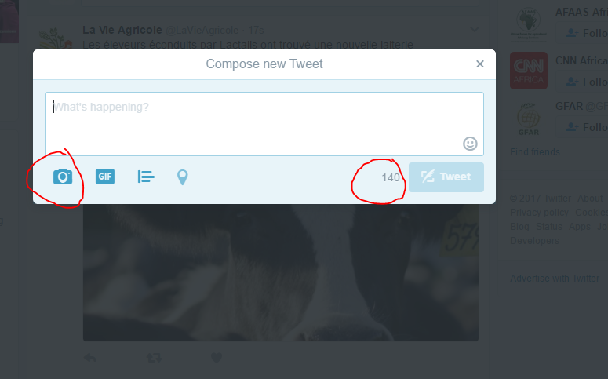
- Click on the “Tweet” icon to draft your post. Write your text. Keep it short! The grey numbers next to the “Tweet” button will tell you how many characters you have left to use. (Characters are letters, punctuation, and spaces.)
- Click on the camera and upload a picture.
- Copy and past a link if you are sharing a news story (or Barza Wire story)! This will use some of the 140 characters available – usually 23 characters for a full link.
- Add hashtags – add # to keywords or tag organizations (using @) -- This is a good way to acknowledge people who created the content or to engage people who will be interested in the content.
- Tweet!

Tips for sharing agricultural news and stories from other sources:
- Read the story to ensure it is relevant to our audience: broadcasters reaching small-scale farmers
- Re-tweet from original source, either the publication or the media organization’s Twitter account. This will make that organization aware of your interest and engagement with their content.

Note: You can schedule Twitter posts in advance using Hootsuite or Twuffer. You can write the posts, and then fix the time and date for publication. I do this for all the posts of Barza Wire content. This way I spend just one day a week working on Barza’s social media. But remember to check Twitter daily to share interesting breaking news.

Personal account

You can also promote Barza Wire from your personal account.
- Retweet or like Barza’s Tweets
- Share our stories from the Barza Wire site
- Share news stories from your account, tagging @BarzaFM
- Retweet Barza’s posts, tagging (@) broadcasters that might find it interesting
- Invite your writers or fellow journalists to follow BarzaFm

Facebook:

Frequency: Once or twice a day

Content schedule:
Tues -- Share full issue + Top story
Wed -- Share Farmer stories
Thu -- Share Resource, Script
Fri -- Share Spotlight, farmer quote (top Farmer story)
Mon -- Share top Farmer story / related farmer stories

Steps for sharing Barza Wire content

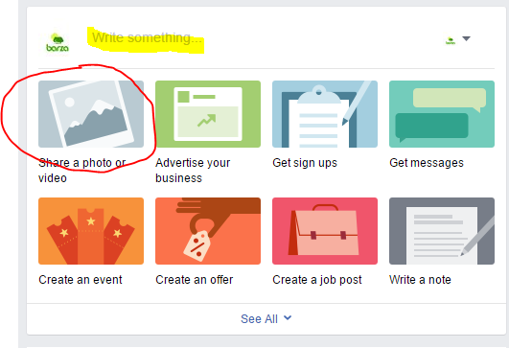
- Start a new post by beginning to write or by clicking on “Share a photo or video.” Write a short promo for the link/photo you are sharing, or ask a question.
- Click on the camera icon to add photos.
- Add a link to the Barza Wire story or content you are sharing
- Share it!

Note: You can also schedule posts in advance by using “Publishing tools” or other programs such as Hootsuite and Twuffer. This will allow you to write the post and fix the date / time for it to go live.

Personal FB
You can also use your personal Facebook account to promote Barza Wire!
- Like the Barza page and invite friends
- Like the Barza posts and share Barza Wire stories yourself; or post a comment on a Barza post
- Share a Barza post, tagging broadcasters / journalists who might find the story interesting

